**Karan Arora**  **R.L. Institute M: 9416974837**

**Max Time : 2 hr** **Class = 12th Biology Test Max Marks : 50**

**Topic: Unit – 1 (Reproduction)**

**Section – A [ 1 X 10 = 10 ]**

1. In a cereal grains, the single cotyledon of embryo is represented by

|  |  |  |  |
| --- | --- | --- | --- |
| a) Coleoptile | b) Coleorhiza | c) Scutellum | d) Hypocotyl |

1. In angiosperm, male gametes are formed by the division of :

|  |  |
| --- | --- |
| a) Microspore mother cell | b) Microspore |
| c) Generative cell | d) Vegetative cell |

1. Filiform apparatus forms the function of :

|  |  |
| --- | --- |
| a) Opening the pollen tube | b) Guiding the pollen tube to egg |
| c) Entry of pollen tube into synergids | d) Prevents growth of more than one tube |

1. Which hormone of pituitary regulates sertoli cells:

|  |  |  |  |
| --- | --- | --- | --- |
| a) LH | b) FSH | c) GH | d) Prolactin |

1. Which among the following has 23 chromosomes :

|  |  |  |  |
| --- | --- | --- | --- |
| a) Spermatogonia | b) Zygote | c) Secondary oocyte | d) Oogonia |

1. Morula is developmental stage of :

|  |  |
| --- | --- |
| a) Between the zygote and blastocyst | b) Between the blastocyst and gastrula |
| c) after the implantation | d) Between implantation and parturition |

1. Mature Graafian follicle is generally present in the ovary of healthy human female around.

|  |  |
| --- | --- |
| a) 5 – 8 day of menstrual cycle | b) 11 – 17 day of menstrual cycle |
| c) 18 – 23 day of menstrual cycle | d) 24 – 28 day of menstrual cycle |

1. The method of direct injecting a sperm into ovum in Assisted reproductive technology is called

|  |  |  |  |
| --- | --- | --- | --- |
| a) GIFT | b) ZIFT | c) ICSI | d) ET |

1. Lactational amenorrhoea means :

|  |  |
| --- | --- |
| a) Absence of menstruation during pregnancy | b) Absence of menstruation during lactation |
| c) excessive bleeding during menstruation | d) No production and secretion of milk |

1. Medical termination of pregnancy is safe upto :

|  |  |
| --- | --- |
| a) 8 weeks of pregnancy | b) 12 weeks of pregnancy |
| c) 18 weeks of pregnancy | d) 24 weeks of pregnancy |

**Section – B [ 1 X 5 = 5 ]**

1. The path of sperm transport is given below. Provide the missing steps in blank boxes.

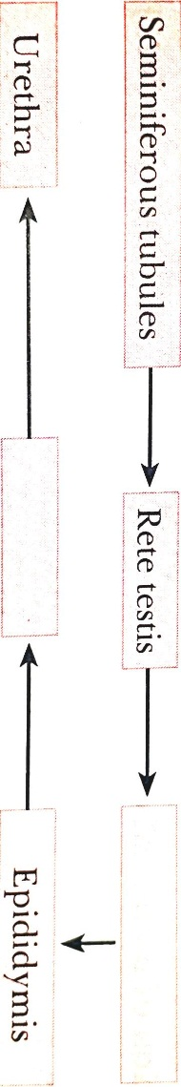

1. Explain the function of Umbilical cord.
2. Reproductive health refers only to healthy reproductive functions. Comment
3. Give an example of a plant which came into India as a contaminant and is a cause of pollen allergy.

Or

Define Endosporic development.

1. Explain Parthenocarpy.

**Section – C [ 2 X 5 = 10 ]**

1. Differentiate between Albuminous and non-Albuminous seeds, giving one example of each.
2. Where is Acrosome present in humans? Write its function.
3. How cm childless couples be helped by the following Assisted reproductive technologies :

(a) GIFT (b) ICSI

1. Why is MTP carried out?
2. A non-biology person is quite shocked to know that apple is false fruit, mango is true fruit and banana is seedless fruit. As a biology student how would you satisfy this person?

Or

What is parturition? Which hormone are involved in parturition?

**Section – D [ 3 X 5 = 15 ]**

1. Suggest the aspects of reproductive health which need to be given special attention in the present scenario.
2. What is oogenesis? Give a brief account of oogenesis.
3. What is triple fusion? Where and how does it takes place? Name the nuclei involved in triple fusion.

Or

With a neat diagram and explained the 7-celled, 8 nuclei nature of the female gametophyte

1. Make a list of any three outbreeding devices that flowering plants have developed and explain how they help to encourage cross-pollination.
2. (i) List any two types of IUDs that re available for human females and state their mode of action.

(ii) Define : (a) Periodic abstinence (b) Coitus interrupts

**Section – E [ 5 X 2 = 10 ]**

1. What is menstrual cycle? Explain the menstrual phase in human female.
2. A flower of Brinjal plant following the process of sexual reproduction produces 360 viable seeds. Answer the following questions by giving reasons.
3. How many ovules are minimally involved?
4. How many megaspore mother cells are involved?
5. What is the minimum number of pollen grin that must land on stigma for pollination?
6. How many male gametes are involved in the above case?
7. How many microspore mother cells must have undergone reduction division prior to dehiscence of another in above case?